Bidder Collector Interfaces' Criteria

* The diagram of bidder collector. See the red text as below.

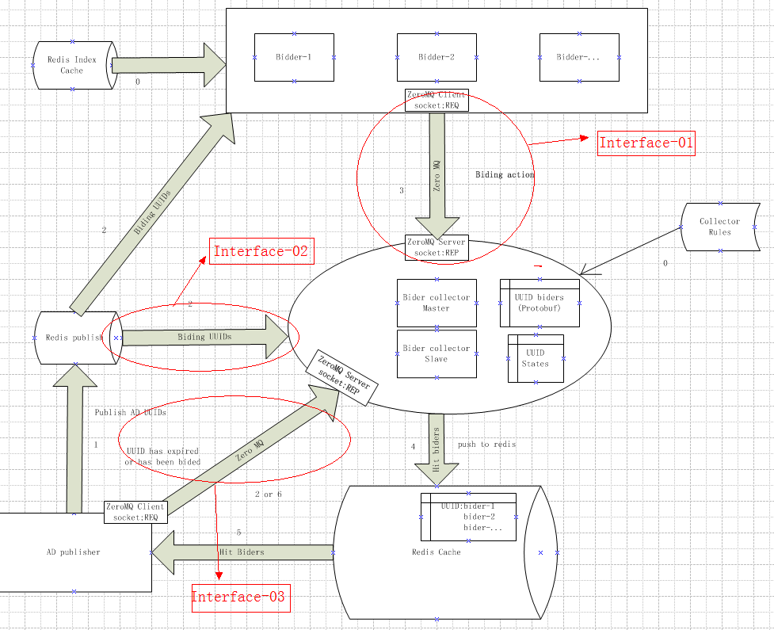

* **Interface-01**

This interface is for that the Bidders submit bidding requests to **Bidder Collector**:

* Communication Method:

ZeroMQ: REQ(Bidder)-->REP(Bidder Collector)

URL: tcp://x.x.x.x:5001

1) When Bidder send a bidding request to Bidder Collector ,The Bidder Collector will reply a "OK". if Bidder does not receive a "OK" response, it should re-send the bidding request.

2) If a bidding activity requested by Bidder is expired , Bidder Collector will reply a "EXPIRED"

* Bidding Request Message Format in protobuf:

**message** CommonMessage{

**required** **string** businessCode = 1;

**optional** **string** dataCodingType = 2;

**required** **bytes** data = 3;

}

Notes:

the **businessCode** field is a code of business definition.

the **dataCodingType** field is a coding type of **data** field. it is optional. if it is null or blank,Bidder Collector will treat the **data** field without decoding.

The **data** field should be a **response.proto**.

* **Interface-02**

This interface is for that Ad Publishers publish UUIDs of AD to **Bidder Collector**

* Communication Method:

Redis: PUB(Ad Publisher)-->SUB(Bidder Collector)

* Bidding Activity Message Format in protobuf:

Same to the Interface-01's bidding request

* **interface-03**

this interface is for that Ad Publisher notify **Bidder Collector** that Ad bidding activity is expired

* Communication Method:

ZeroMQ: REQ(Bidder)-->REP(Bidder Collector)

URL: tcp://x.x.x.x:5002

NOTE: When Bidder send a bidding request to Bidder Collector ,The Bidder Collector will reply a "OK". if Bidder does not receive a "OK" response, it should re-send the bidding request.

* Expired Message Format in protobuf:

**message** CommonMessage{

**required** **string** businessCode = 1;

**optional** **string** dataCodingType = 2;

**required** **bytes** data = 3;

}

The **data** field protobuf:

**message** ExpiredMessage{

**required** **string** uuid = 1;

**required** **string** status = 3;

}